1. Setup physical Connection.
2. Power on the phone
3. Configure Server interface.
4. Configure DHCP.
5. Configure Call Manager telephony service
6. Configure voice v LAN on switch.
7. Assign numbers to IP phones.
8. Call the phones.

3. 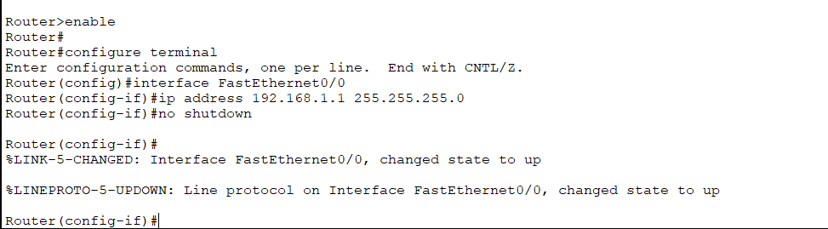

Screenshots:

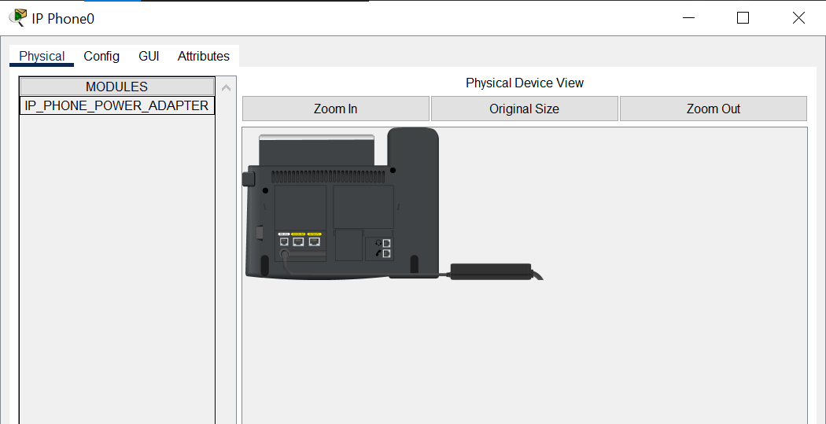

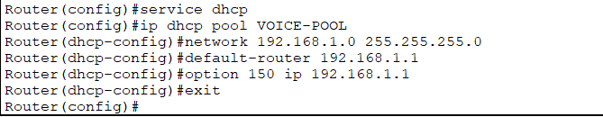

Option 150 tells the router to enable the TFTP server using 192.168.1.1 interface

